CPS 2 Homework 8

1. 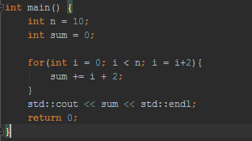
   1. O(n/2)
   2. 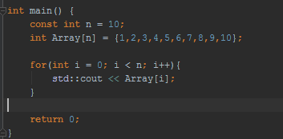O(n)
   3. O(n)
   4. O(n) ?
   5. O(1)
   6. O(n)
   7. Best case: O(1) Worst Case: O(n) Avg Case: O(n/2)
   8. Best case: O(1) Worst Case: O(log(n)) Avg Case: O(log(n))
   9. O(n) You have to move everything out of the way to add another element
   10. O(1) You can just throw it on and not worry about it
2. 1. Big O for loop A is O(n) and loop b is O(n^2)
   2. As long as n is less than 10000 then loop B is faster because it doesn’t have to iterate through the second loop as long but as soon as it’s equal then loop A will be faster.